Information Sheet

Study title: Comparing behaviour-management and clinician-assisted neurocognitive training to reduce symptoms in children with AD/HD

Researchers: Professor Stuart Johnstone, Zachary Churchill, Laura Mccabe, Michelle Mendez, Hannah Pearce, Taylah Smede, Melinda Hickey, School of Psychology, University of Wollongong, Wollongong, Australia

This is an invitation to contribute to a new study which will compare a newly-developed clinician-assisted neurocognitive treatment for children with AD/HD against treatment-as-usual involving behaviour-management.

What is the aim of the study?
The overall study aims to compare behaviour-management and clinician-assisted neurocognitive interventions for children with AD/HD. To do this, we need to look at three groups - each of which will complete a set of outcomes measures about 11 weeks apart:
- Children with AD/HD who do not complete an intervention
- Children with AD/HD who do complete an intervention
- Typically-developing children who do not complete an intervention.

In this instance, we seek your child’s involvement as part of group 1.

What will your child do?
As part of this study your child will undertake the following tasks:
- A 30 minute assessment of brain activity and executive function ability, and sleep and psychological needs questionnaires. This will take place at the University or at a location convenient to you and your child.
- A second 30 minute assessment of brain activity and executive function ability, and sleep and psychological needs questionnaires about 11 weeks after the first assessment. This will take place at the University or at a location convenient to you and your child.

Some examples of the types of items in the questionnaires your child will complete include:
- Make a rating on the statement “In a normal day I mostly have to do what I am told”
- Answer the question “After you fell asleep, did you wake up during the night?”
- Make a rating on the statement “I have no problems doing my usual activities”

What will you do?
As part of this study you will undertake the following tasks:
- Assessment session 1 - complete 3 questionnaires about your child. This will take 15-20 minutes.
- Provide your child’s teacher’s email address so that we can request they complete a 40-item questionnaire about your child just after assessment session 1 and assessment session 2.
- Assessment session 2 - complete 3 questionnaires about your child. This will take 15-20 minutes.

Some examples of the types of items in the questionnaires you will complete include:

- Make a rating on “Often has difficulty maintaining alertness, orienting to requests, or executing directions”
- Make a rating on the statement “People my child are with each day take care of his/her feelings”
- Make a rating on the statement “[my child] Waits their turn in activities”.

Important things to consider
- Participation in the study is voluntary.
- All data obtained will be used only for the purposes of this study and will not be made available to any persons other than the research team. Confidentiality is assured and no individual will be identifiable. The data may be considered at a group level to examine the effects of the different treatments and this may be written for publication in a scientific journal is deemed appropriate by the researcher. If you or your child choose to withdraw your consent to participate, your data will be destroyed and not included in any group analyses.

The assessment hardware
All children in the study will use the NeuroSky Mindwave device (see picture below) for the assessment sessions. This device is very safe. The electrodes on this device receive tiny electrical signals that the brain generates at all times. The device does not generate electricity or radiation and will not harm your child. Your child will experience no discomfort and the skin is not penetrated.

The NeuroSky Mindwave (right) is worn like a set of headphones. Small dry sensors rests against the forehead and another is in the earlobe clip. The device measures the brain’s electrical activity. | 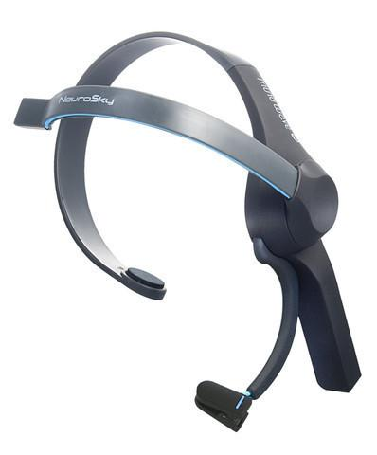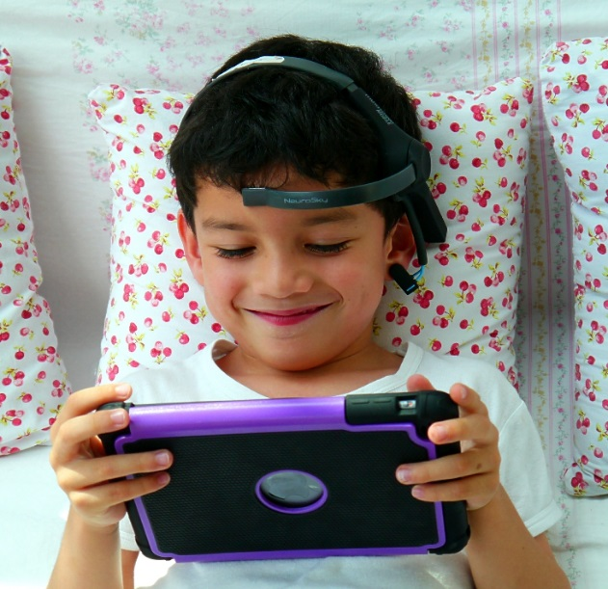

Benefits of Participation
Your child will receive a $25 gift card as a reward for participating. Further, your child contribute to our understanding of retesting on our range of measures. This will allow us to examine our ADHD intervention outcomes, and make better and more effective treatments for children with ADHD.

Risks and burdens of participation
None.

If you have any questions about this research please email or call Professor Stuart Johnstone.

If you would like your child to participate in this research please email or call Professor Stuart Johnstone.

Email: sjohnsto@uow.edu.au
Phone: 02 4221 4495

This project has been approved by the UOW Social Sciences HREC (ethics protocol number 2018/400). If you have any complaints about the conduct of the study please contact the Complaints Officer, University of Wollongong/Illawarra Area Health Service Human Research Ethics Committee on 02 4221 4457 or email ethics@uow.edu.au. Your child’s participation in this research is entirely voluntary, and he/she can refuse to participate, and is free to withdraw from the research, at any time. His/her refusal to participate or withdrawal of consent will not affect any relationship with the School of Psychology at the University of Wollongong.

